**1.Install and set up MySQL.To create a database called Company and define an Employee table with appropriate attributes like EmpID, Name, Designation, Salary. Insert sample data and delete records using SQL queries**.

**CODE:**

CREATE DATABASE Business;

USE Business;

CREATE TABLE Employeee (

EmpID INT PRIMARY KEY,

Name VARCHAR(50),

Designation VARCHAR(50),

Salary DECIMAL(10, 2)

);

INSERT INTO Employeee VALUES (1, 'Aiman', 'Developer', 90000);

INSERT INTO Employeee VALUES (2, 'Jennie', 'Tester', 95000);

DELETE FROM Employeee WHERE EmpID = 2;

SELECT*FROM Employeee;

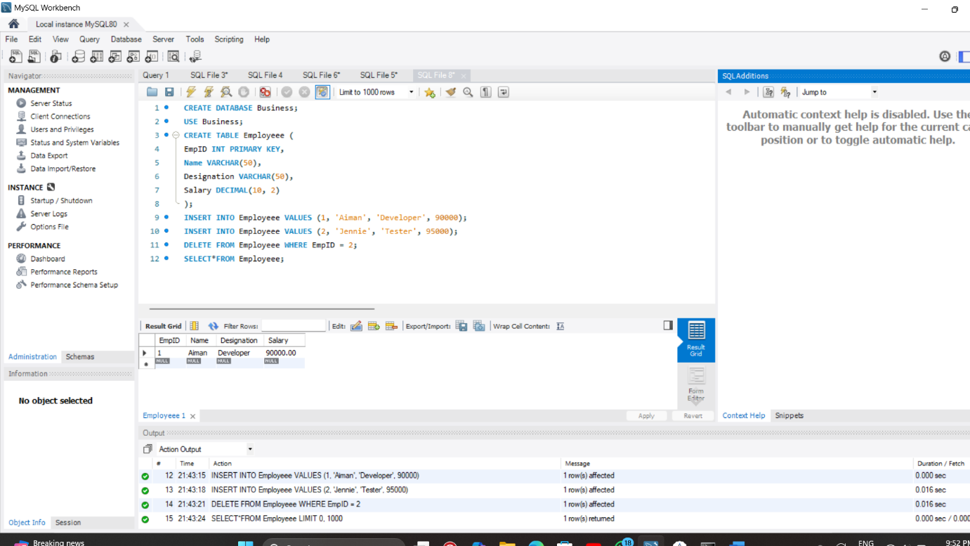

**2. Create a table for storing student information. Insert sample data and perform basic operations: INSERT, UPDATE, DELETE, and SELECT.**

**CODE:**

CREATE DATABASE school;

USE school;

CREATE TABLE studyy(

RollNo INT PRIMARY KEY,

Name VARCHAR(50),

Department VARCHAR(50),

Marks INT

);

INSERT INTO studyy(RollNo , Name, Department,Marks)VALUES

(105, 'Aiman', 'CYBER',99),

(106,'Jennie','CYBER',98),

(107,'Lisa','AIDS',99),

(108,'Rose','AIDS',98);

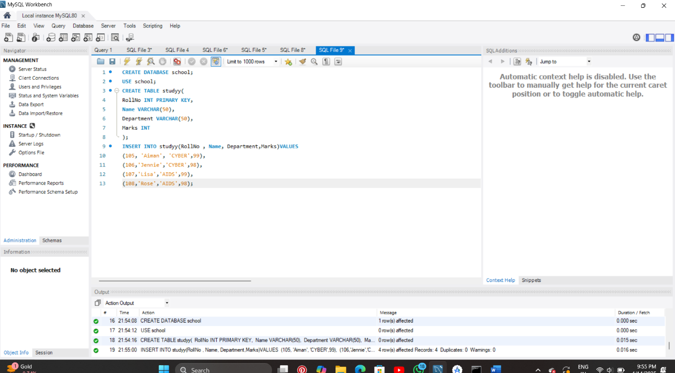

UPDATE Studyy

SET Marks=89

WHERE RollNo=107;

DELETE FROM studyy

WHERE RollNo=105;

SELECT * FROM studyy;

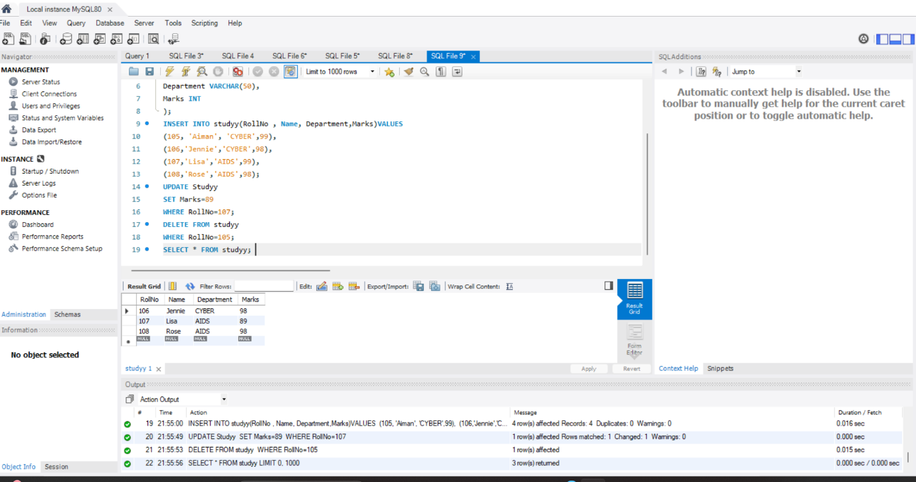

**3. Create a table with columns for EmployeeID, Name, Salary, JoiningDate, and ActiveStatus using different data types. Insert sample data and perform queries to manipulate and retrieve data.**

**CODE:**

CREATE TABLE EmployeeInfo(

EmployeeID INT PRIMARY KEY,

Name VARCHAR(50),

Salary DECIMAL(10,2),

JoiningDates DATE,

ActiveStatus BOOLEAN

);

INSERT INTO EmployeeInfo(EmployeeID,Name,Salary,JoiningDates,ActiveStatus)VALUES

(1, 'AIMAN', 60000.00, '2022-08-01', TRUE),

(2, 'JENNIE', 70000.00, '2022-08-07', TRUE),

(3, 'LISA', 60000.00, '2022-09-01', FALSE),

(4, 'ROSE', 90000.00, '2022-08-01', FALSE),

(5, 'LILY', 68000.00, '2022-10-01', TRUE);

SELECT * FROM EmployeeInfo;

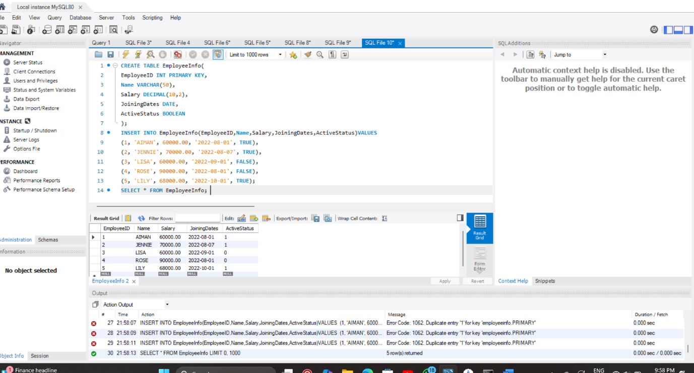

UPDATE EmployeeInfo

SET Salary= Salary+2000

WHERE ActiveStatus=TRUE;

SELECT * FROM EmployeeInfo

WHERE ActiveStatus=TRUE;

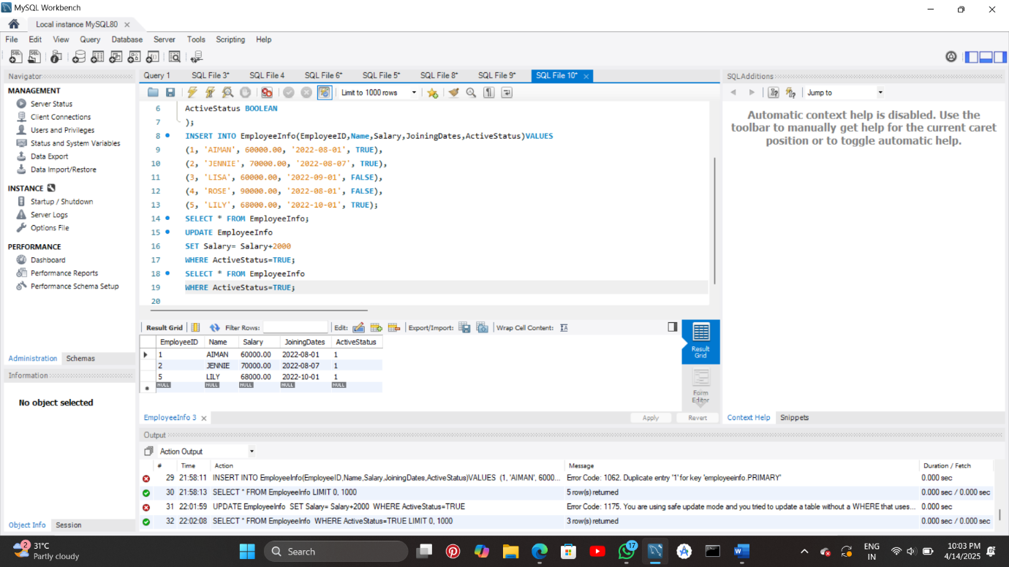

SELECT * FROM EmployeeInfo

WHERE JoiningDates >

'2022-01-01';

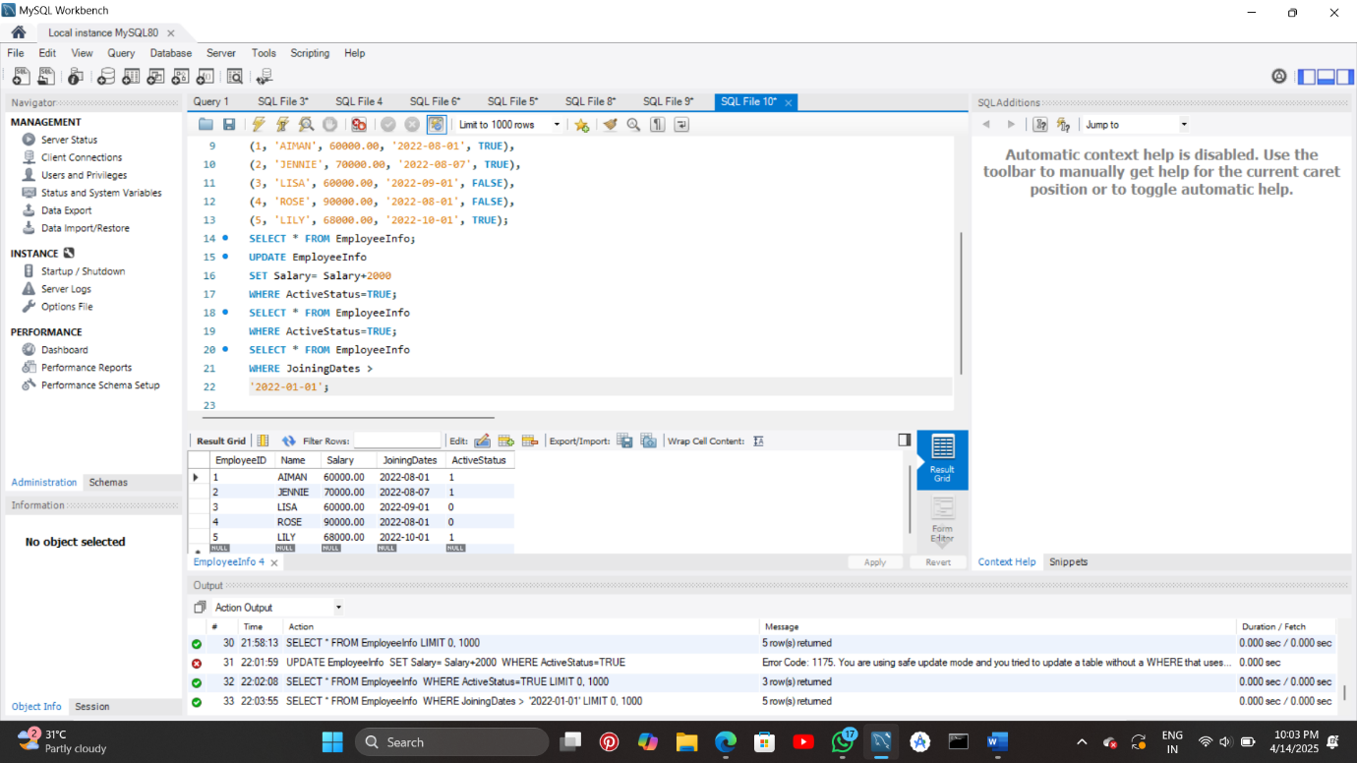

**4. Create a table to store employee information with constraints like Primary Key, Foreign Key, and Unique. Insert valid and invalid data to test the constraints.**

**CODE:**

CREATE DATABASE INFORMATION;

USE INFORMATION;

CREATE TABLE Department (

DeptID INT PRIMARY KEY,

DeptName VARCHAR(50) UNIQUE

);

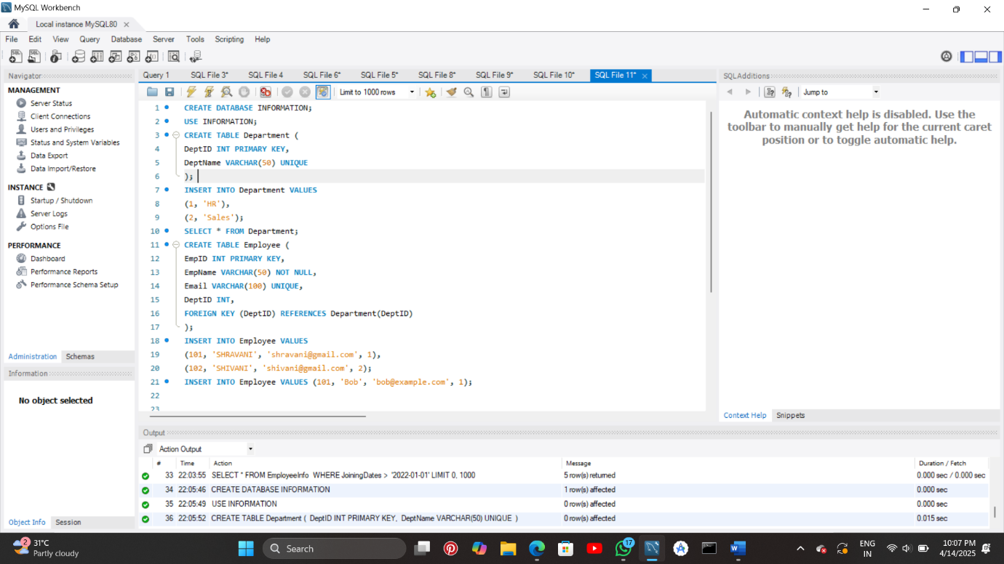

INSERT INTO Department VALUES

(1, 'HR'),

(2, 'Sales');

SELECT * FROM Department;

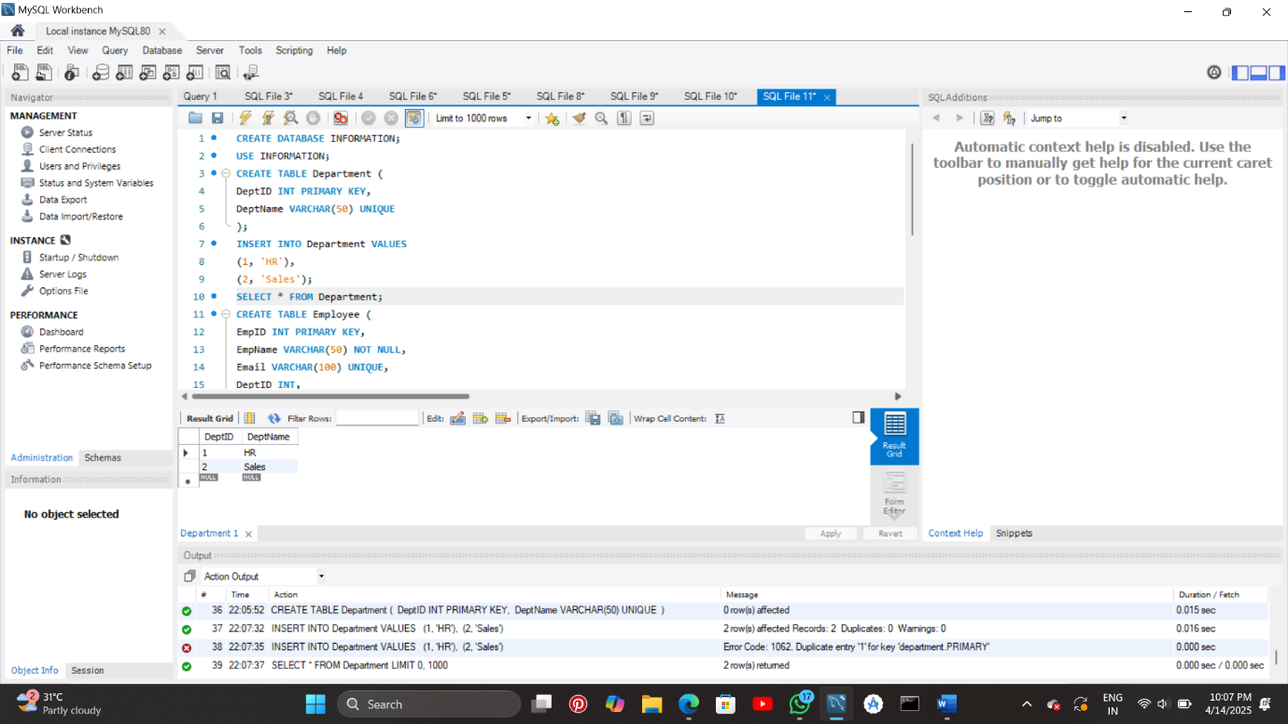

CREATE TABLE Employee (

EmpID INT PRIMARY KEY,

EmpName VARCHAR(50) NOT NULL,

Email VARCHAR(100) UNIQUE,

DeptID INT,

FOREIGN KEY (DeptID) REFERENCES Department(DeptID)

);

INSERT INTO Employee VALUES

(101, 'AIMAN', 'aiman@gmail.com', 1),

(102, 'JENNIE', 'jennie@gmail.com', 2);

INSERT INTO Employee VALUES (101, 'Bob', 'bob@example.com', 1);

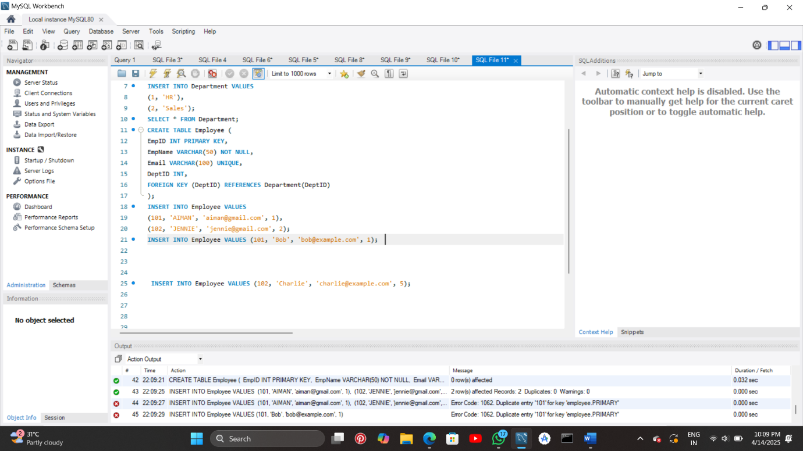INSERT INTO Employee VALUES (102, 'Charlie', 'charlie@example.com', 5); 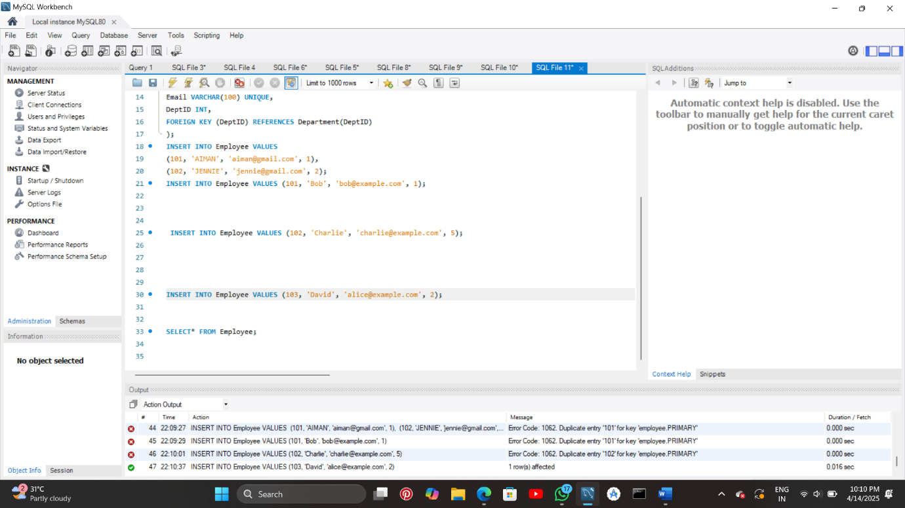

INSERT INTO Employee VALUES (103, 'David', 'alice@example.com', 2);



SELECT* FROM Employee;

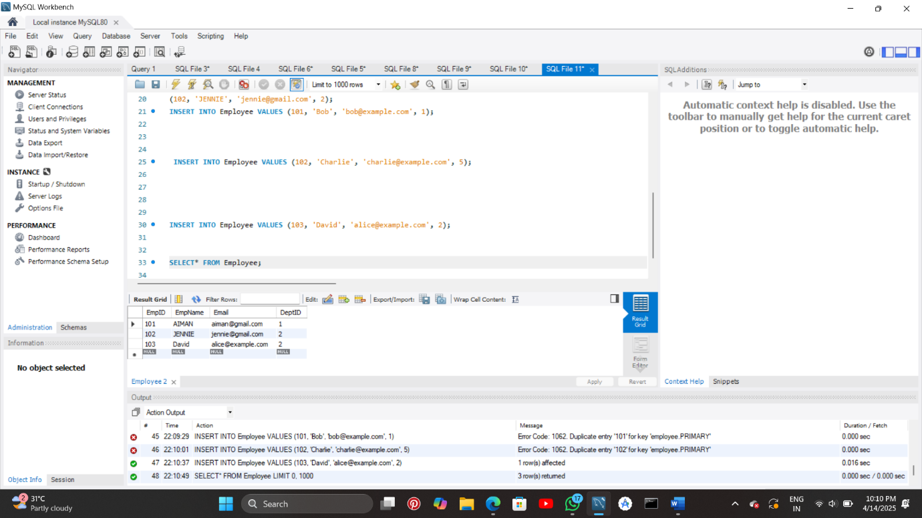

**5. Create a table for Customer details with various integrity constraints like NOT NULL, CHECK, and DEFAULT. Insert valid and invalid data to test these constraints and ensure data integrity.**

**CODE:**

CREATE TABLE CUSTOMERR (

CustID INT PRIMARY KEY,

CustName VARCHAR(50) NOT NULL,

Age INT CHECK (Age >= 18),

City VARCHAR(50) DEFAULT 'UNKNOWN'

);

INSERT INTO CUSTOMERR VALUES

(1, 'AIMAN SHILEDAR', 20, 'New York');

INSERT INTO CUSTOMERR(CustID, CustName, Age) VALUES (2, 'JENNIE', 27);

INSERT INTO CUSTOMERR VALUES (3, NULL, 22, 'LA');

INSERT INTO CUSTOMERR VALUES (4, 'Kid User', 15, 'Delhi');

SELECT * FROM CUSTOMERR;

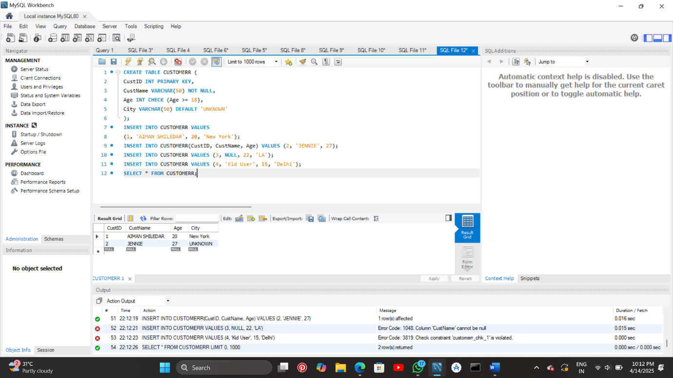

**6. Use DDL commands to create tables and DML commands to insert, update, and delete data. Write SELECT queries to retrieve and verify data changes.**

**CODE:**

CREATE TABLE CUSTOMERR (

CustID INT PRIMARY KEY,

CustName VARCHAR(50) NOT NULL,

Age INT CHECK (Age >= 18),

City VARCHAR(50) DEFAULT 'UNKNOWN'

);

INSERT INTO CUSTOMERR VALUES

(1, 'AIMAN SHILEDAR', 20, 'New York');

INSERT INTO CUSTOMERR(CustID, CustName, Age) VALUES (2, 'JENNIE', 27);

INSERT INTO CUSTOMERR VALUES (3, NULL, 22, 'LA');

INSERT INTO CUSTOMERR VALUES (4, 'Kid User', 15, 'Delhi');

INSERT INTO CUSTOMERR VALUES (4, 'ASH', 15, 'Delhi');

SELECT * FROM CUSTOMERR;

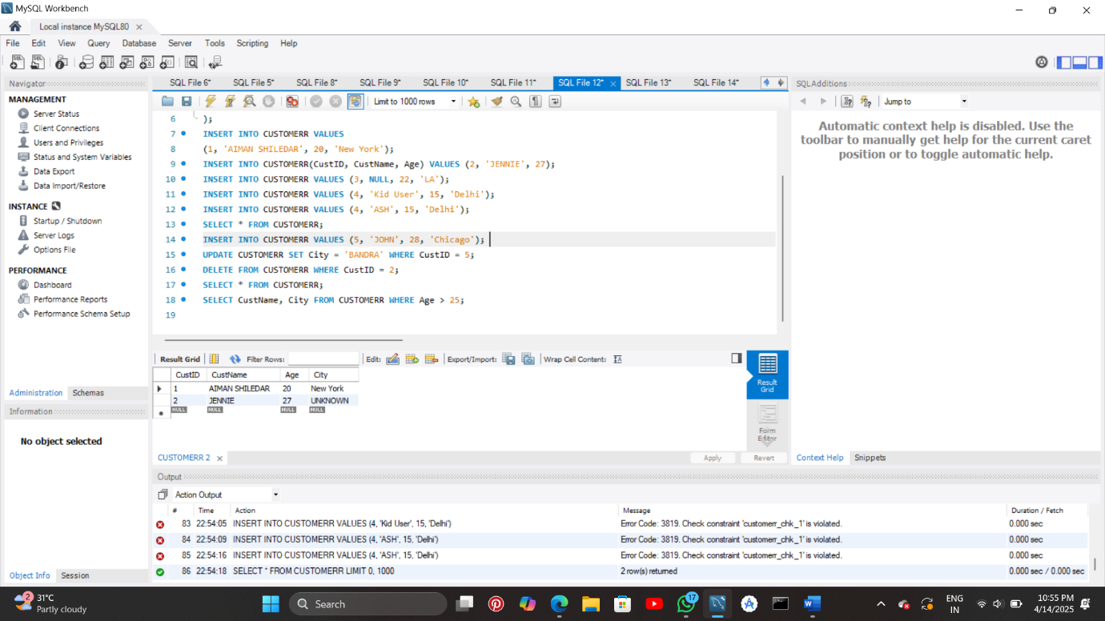

INSERT INTO CUSTOMERR VALUES (5, 'JOHN', 28, 'Chicago');

UPDATE CUSTOMERR SET City = 'BANDRA' WHERE CustID = 5;

DELETE FROM CUSTOMERR WHERE CustID = 2;

SELECT * FROM CUSTOMERR;

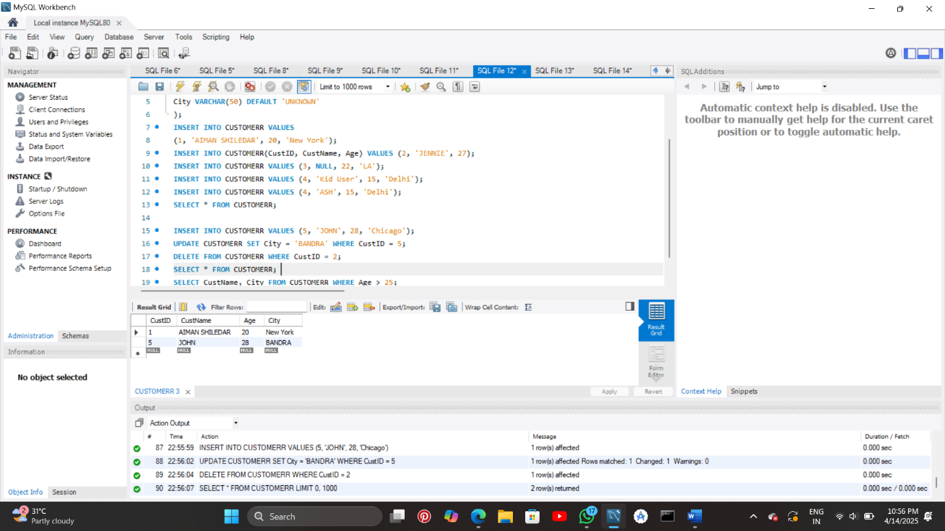

SELECT CustName, City FROM CUSTOMERR WHERE Age > 25;

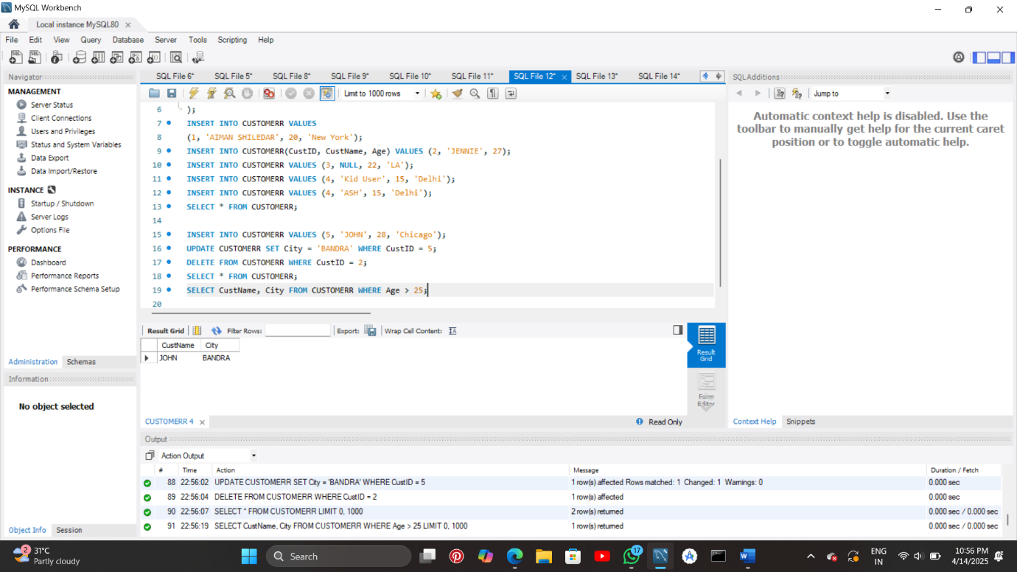

**7. Create a Sales table and use aggregate functions like COUNT, SUM, AVG, MIN, and MAX to summarize sales data and calculate statistics.**

**CODE:**

CREATE TABLE Sales (

SaleID INT PRIMARY KEY,

Product VARCHAR(50),

Quantity INT,

Price DECIMAL(10, 2)

);

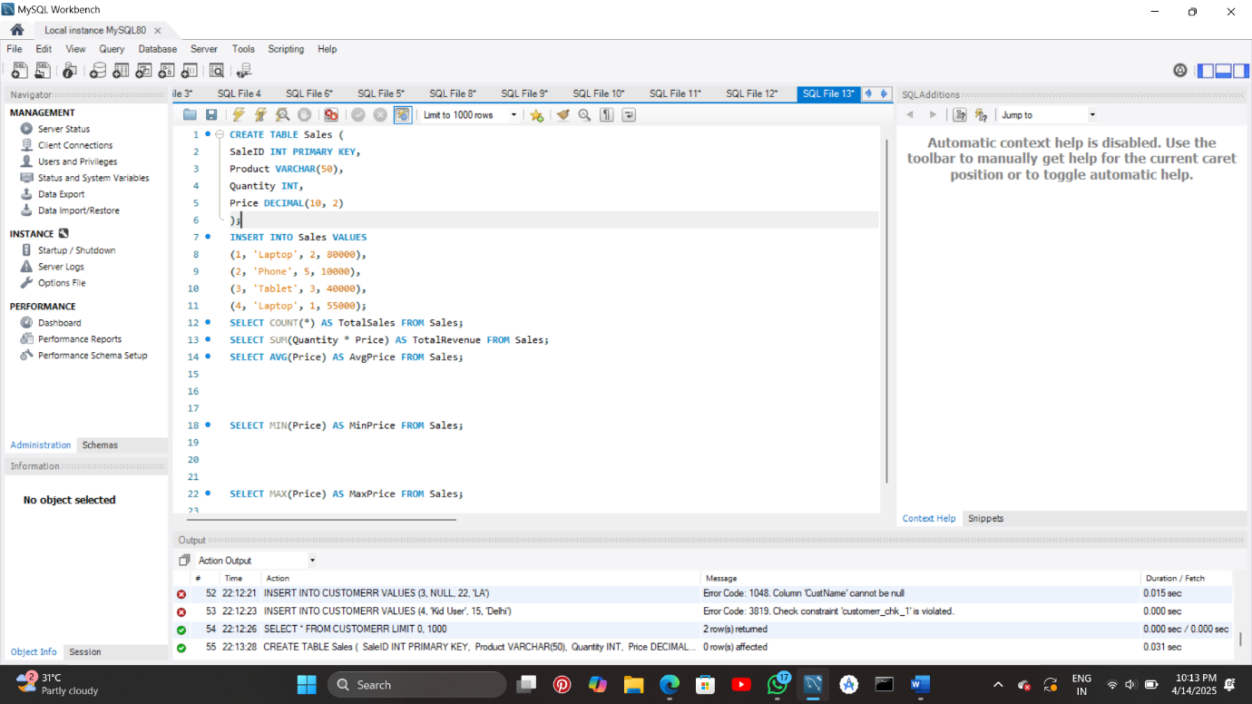

INSERT INTO Sales VALUES

(1, 'Laptop', 2, 80000),

(2, 'Phone', 5, 10000),

(3, 'Tablet', 3, 40000),

(4, 'Laptop', 1, 55000);

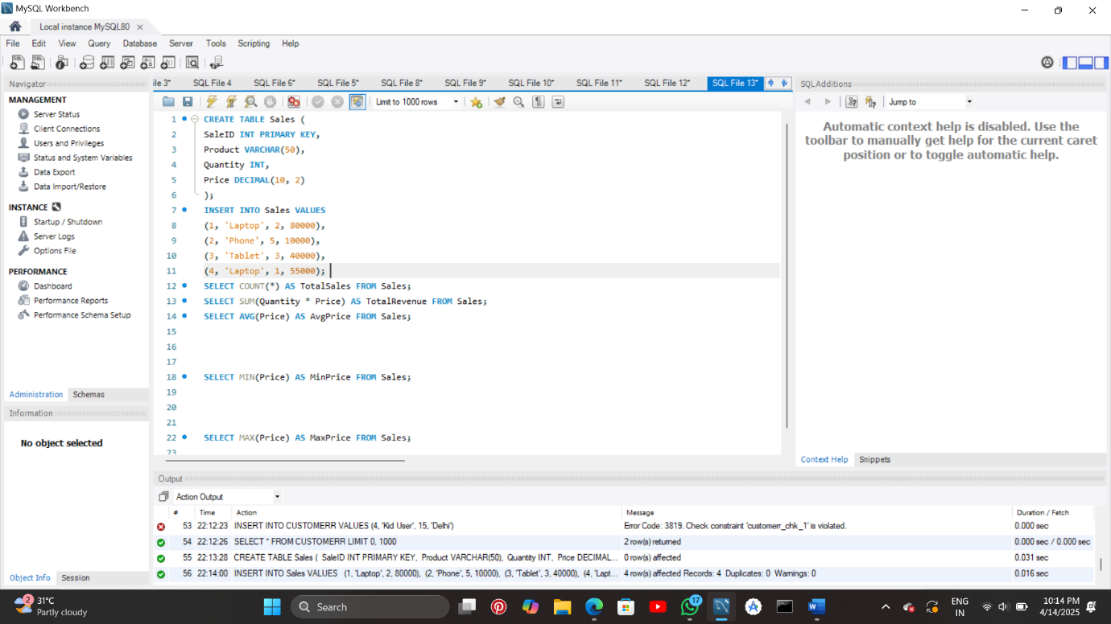

SELECT COUNT(*) AS TotalSales FROM Sales;

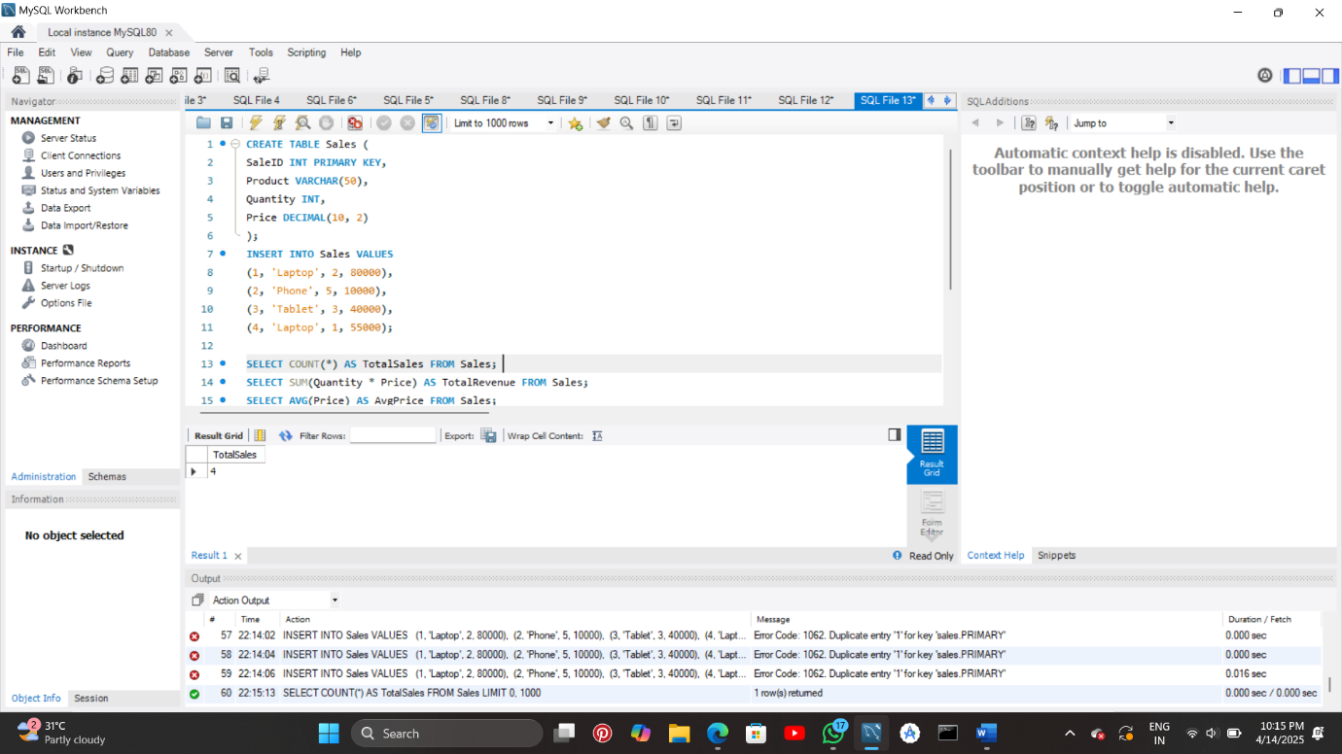

SELECT SUM(Quantity * Price) AS TotalRevenue FROM Sales;

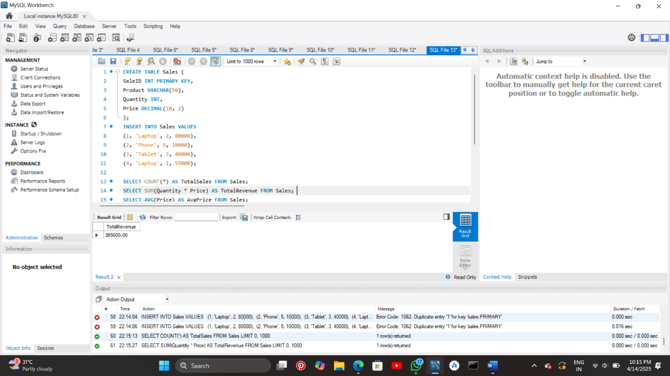

SELECT AVG(Price) AS AvgPrice FROM Sales;

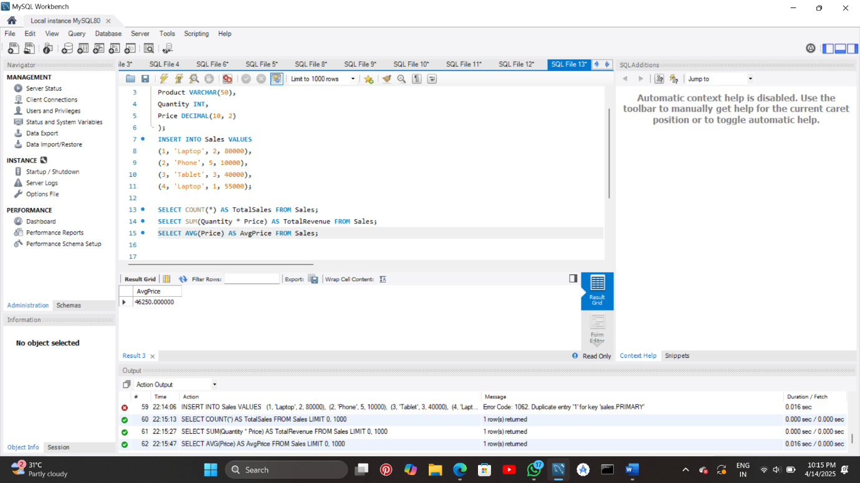

SELECT MIN(Price) AS MinPrice FROM Sales;

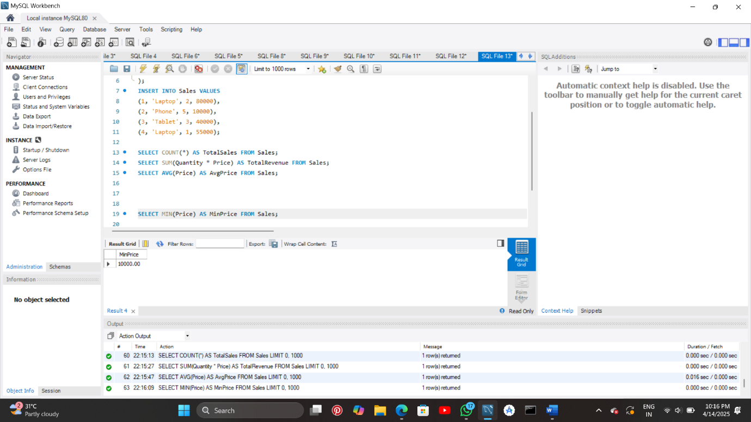

SELECT MAX(Price) AS MaxPrice FROM Sales;

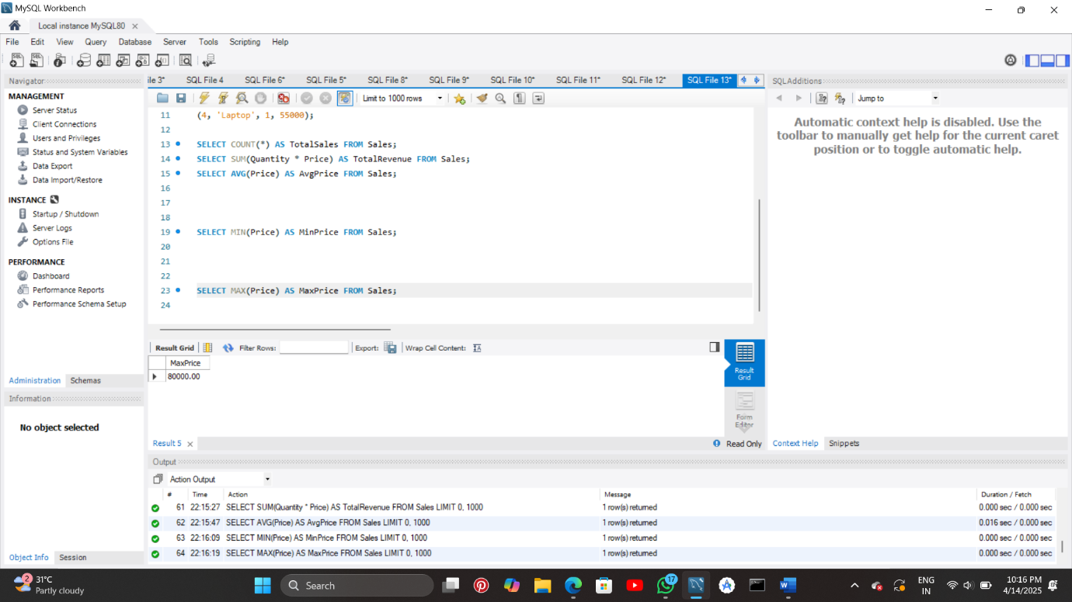

**8. Given Customers and Orders tables, write SQL queries to perform INNER JOIN, LEFT JOIN, and RIGHT JOIN to retrieve combined data for customer orders.**

**CODE:**

CREATE DATABASE CUSTOMER;

USE CUSTOMER;

CREATE TABLE Customers (

CustID INT PRIMARY KEY,

CustName VARCHAR(100),

City VARCHAR(50)

);

INSERT INTO Customers (CustID, CustName, City) VALUES

(1, 'AIMAN', 'Pune'),

(2, 'JENNIE', 'Mumbai'),

(3, 'LISA', 'Nashik'),

(4, 'LILY', 'Delhi');

CREATE TABLE ORDERS (

OrderID INT PRIMARY KEY,

CustID INT,

OrderDate DATE,

Amount DECIMAL(10, 2),

FOREIGN KEY (CustID) REFERENCES Customers(CustID)

);

INSERT INTO ORDERS (OrderID, CustID, OrderDate, Amount) VALUES

(101, 1, '2025-04-01', 2500.00),

(102, 3, '2025-04-05', 1800.00),

(103, 1, '2025-04-07', 3200.00),

(104, 4, '2025-04-09', 1500.00);

SELECT Customers.CustID, Customers.CustName, ORDERS.OrderID, ORDERS.OrderDate,

ORDERS.Amount

FROM Customers

INNER JOIN ORDERS ON Customers.CustID = ORDERS.CustID;

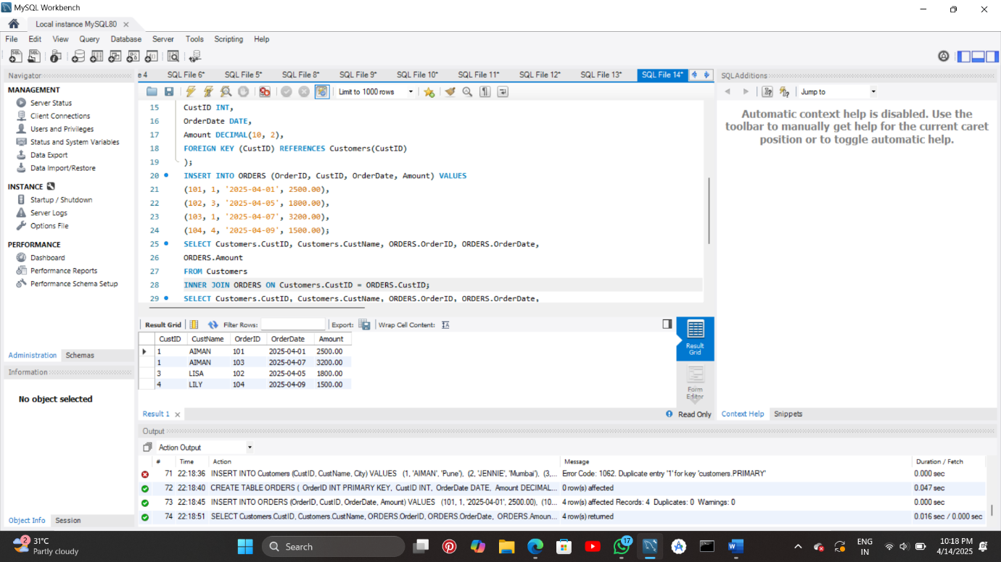

SELECT Customers.CustID, Customers.CustName, ORDERS.OrderID, ORDERS.OrderDate,

ORDERS.Amount

FROM Customers

LEFT JOIN ORDERS ON Customers.CustID = ORDERS.CustID;

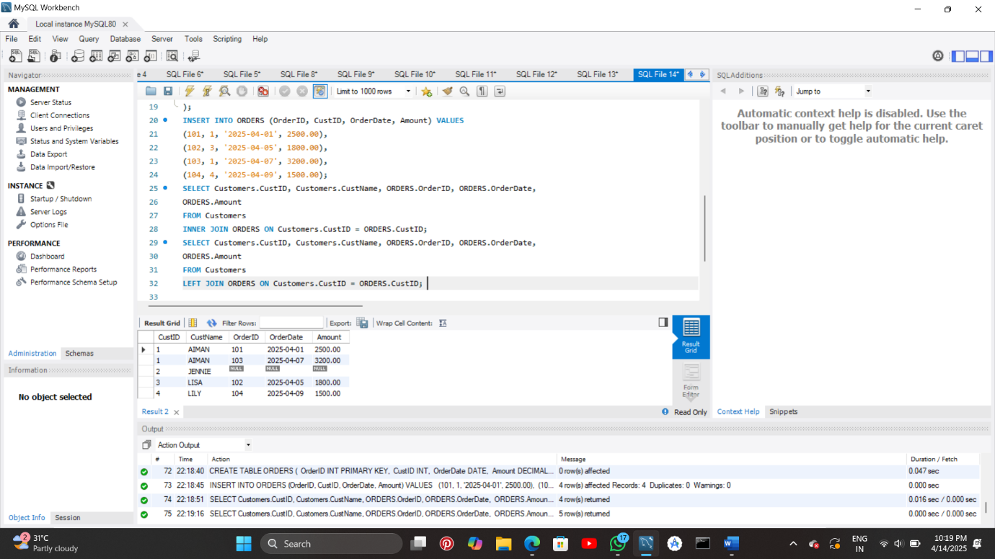

SELECT Customers.CustID, Customers.CustName, ORDERS.OrderID, ORDERS.OrderDate,

ORDERS.Amount

FROM Customers

RIGHT JOIN ORDERS ON Customers.CustID = ORDERS.CustID;

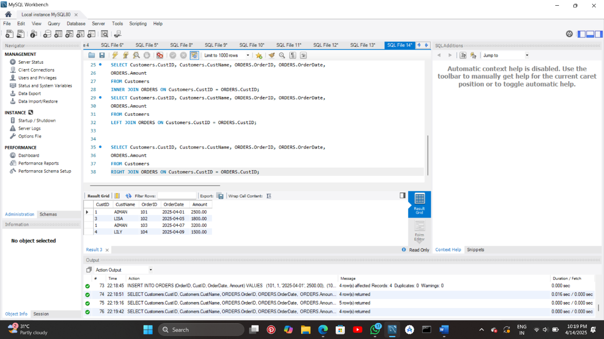

**NAME: Aiman Shiledar**

**PRN: 2124UCSF1035**

**DEPARTMENT: F.Y Cybersecurity**